End Semester Project Report
Project title
WEATHER FORECASTING FOR ISLAMABAD USING LSTM AND GRU NETWORKS

Abstract
Accurate short-term weather forecasting plays a critical role in agriculture, urban planning, disaster preparedness, and daily human activities. Traditional numerical weather prediction models, while effective at large scales, often struggle to provide precise localized short-term forecasts due to their high computational complexity and dependence on physical assumptions. This project presents a data-driven deep learning approach for forecasting the next 24 hours of weather conditions in Islamabad, Pakistan. Hourly historical meteorological data consisting of temperature, relative humidity, and precipitation were collected using the Open-Meteo API. Long Short-Term Memory (LSTM) and Gated Recurrent Unit (GRU) neural networks were employed to model temporal dependencies within the data. The models were trained to predict the next 24 hours using the previous 24 hours as input. Performance was evaluated through loss curves and direct comparison of predicted versus actual values. The results demonstrate that both LSTM and GRU models are capable of capturing diurnal patterns and producing realistic short-term forecasts, with minor performance differences across weather variables.
1. Introduction
Weather forecasting has traditionally relied on physics-based numerical models that simulate atmospheric dynamics using complex differential equations. Although these models are powerful, they require substantial computational resources and often lack precision at localized and short-term horizons. In recent years, machine learning and deep learning techniques have emerged as promising alternatives due to their ability to learn patterns directly from historical data.
Time-series forecasting is particularly well-suited for recurrent neural networks, as weather variables exhibit strong temporal dependencies and seasonal cycles. Among recurrent architectures, Long Short-Term Memory (LSTM) and Gated Recurrent Unit (GRU) networks are widely used because they address the vanishing gradient problem and can retain information over extended sequences. This project applies LSTM and GRU models to hourly weather data from Islamabad with the objective of predicting temperature, humidity, and precipitation for the next 24 hours.
2. Problem Statement
Short-term weather forecasts in Pakistan often lack sufficient spatial and temporal resolution for localized decision-making. This limitation affects sectors such as agriculture, water resource management, and urban planning. The problem addressed in this project is the development of a reliable and localized forecasting system capable of predicting the next 24 hours of key meteorological parameters using historical time-series data and deep learning techniques.
3. Objectives
The primary objective of this project is to design and evaluate a deep learning–based system for next-day weather prediction. Specifically, the project aims to collect and preprocess hourly weather data for Islamabad, clean and normalize the dataset for time-series modeling, train LSTM and GRU neural networks for multivariate forecasting, visualize model performance through appropriate plots, and generate numerical predictions for the next 24 hours.
4. Dataset Description
The dataset used in this study was obtained from the Open-Meteo API, which provides free and reliable meteorological data. Hourly weather observations for Islamabad were collected over a continuous period of approximately 60–90 days. The dataset includes three primary variables: temperature measured in degrees Celsius, relative humidity expressed as a percentage, and precipitation measured in millimeters. The hourly resolution of the data makes it particularly suitable for capturing daily weather cycles and short-term fluctuations.
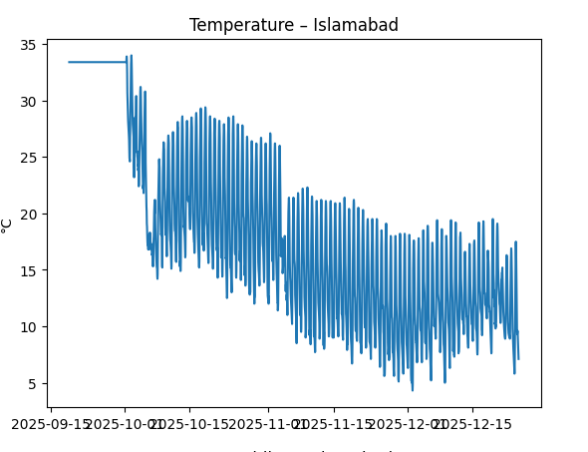
Figure 1 Hourly Temperature Trend
This figure illustrates the hourly temperature variation over the selected time period. A clear diurnal pattern is visible, with temperatures rising during the day and falling at night. Such cyclic behavior confirms the suitability of sequence-based models for this task.
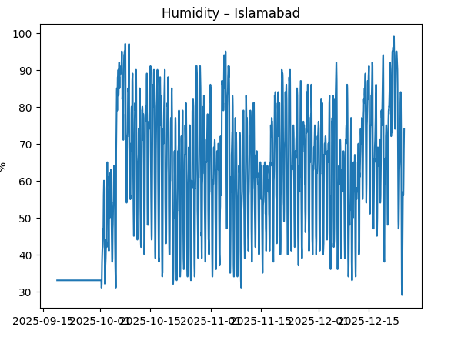
Figure 2 Hourly Humidity Trend
The humidity plot shows an inverse relationship with temperature, where higher humidity levels often occur during cooler hours. This interdependence justifies the use of multivariate forecasting.
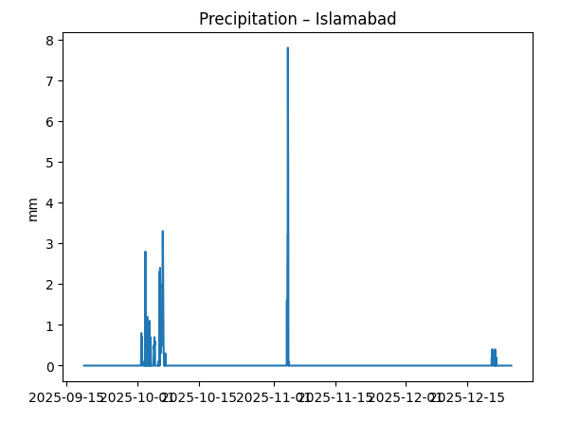
Figure 3 Hourly Precipitation Trend
Precipitation values are sparse and irregular, characterized by sudden spikes corresponding to rainfall events. This irregularity makes precipitation the most challenging variable to predict.
5. Data Cleaning and Preprocessing
Raw meteorological data often contain missing values and inconsistencies due to sensor limitations or transmission errors. In time-series forecasting, improper handling of missing values can disrupt temporal continuity. In this project, interpolation was deliberately avoided because it can introduce artificial trends and distort true temporal patterns. Instead, forward filling and backward filling techniques were used to preserve continuity while maintaining realistic values. Duplicate timestamps were removed to ensure chronological consistency.
6. Sequence Generation
To convert the cleaned dataset into a supervised learning format, a sliding window approach was adopted. For each training sample, the previous 24 hours of weather data were used as input, while the subsequent 24 hours served as the target output. Each input sequence therefore consists of 24 time steps with three features, and each output sequence predicts 24 future values for the same three features. This formulation directly aligns with the objective of next-day forecasting.
7. Model Architecture
This project employs two recurrent neural network architectures—Long Short-Term Memory (LSTM) and Gated Recurrent Unit (GRU)—to model the temporal dependencies present in hourly weather data. Both models are designed with similar depth and capacity to ensure a fair comparison.
The input to each model is a multivariate time-series sequence representing the previous 24 hours of weather observations. Each time step contains three features: temperature, relative humidity, and precipitation. Consequently, the input shape to the models is (24, 3).
7.1 LSTM Architecture
The LSTM model consists of two stacked recurrent layers followed by a fully connected output layer. The first LSTM layer contains 64 units and is configured to return sequences, enabling the model to pass temporal information across all time steps to the next layer. A Dropout layer with a rate of 0.2 is applied to reduce overfitting.
The second LSTM layer contains 32 units and outputs only the final hidden state, which represents a condensed summary of the learned temporal patterns. This output is fed into a Dense layer with 72 neurons, corresponding to the prediction of 24 future hours for three weather variables (24 × 3). The Dense output is reshaped into a (24, 3) format to obtain hour-wise forecasts
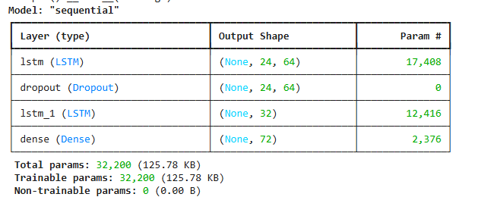
Figure 4 LSTM Architecture
7.2 GRU Architecture
The GRU model follows an architecture similar to the LSTM model to maintain consistency. It comprises two GRU layers with 64 and 32 units, respectively. The first GRU layer returns sequences, while the second outputs the final hidden state. A Dropout layer (0.2) is applied between the recurrent layers to improve generalization.
As in the LSTM model, the output is produced by a Dense layer with 72 neurons, which generates predictions for the next 24 hours of temperature, humidity, and precipitation. The GRU model benefits from a simpler gating mechanism, resulting in reduced computational complexity while achieving comparable performance.
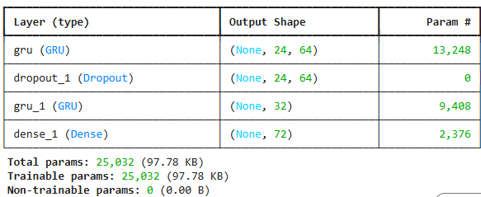
Figure 5 GRU Architecture
7.3 Training Configuration
Both models are trained using the Adam optimizer and Mean Squared Error (MSE) loss function, which is suitable for continuous-valued regression tasks. Identical training settings are used for both architectures to ensure a fair evaluation.
8. Model Training
Both models were trained using the Adam optimizer and Mean Squared Error (MSE) as the loss function. The dataset was split into training and testing sets, and a validation split was used during training to monitor generalization performance.
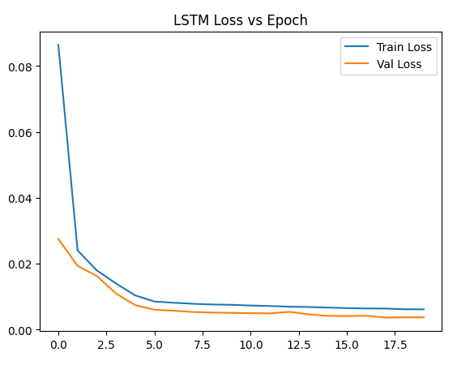
Figure 6
The loss curve shows steady convergence, indicating stable learning and no severe overfitting.
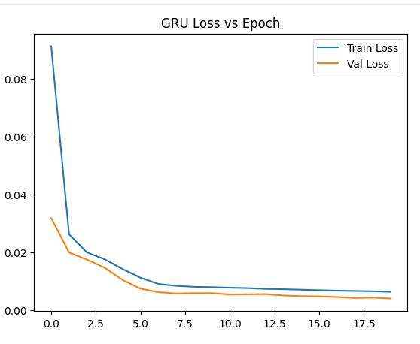
Figure 7
The GRU model exhibits similar convergence behavior, confirming effective training.
9. Model Evaluation and Comparison
To evaluate forecasting performance, predicted values were compared with actual observations over a 24-hour horizon from the test set.
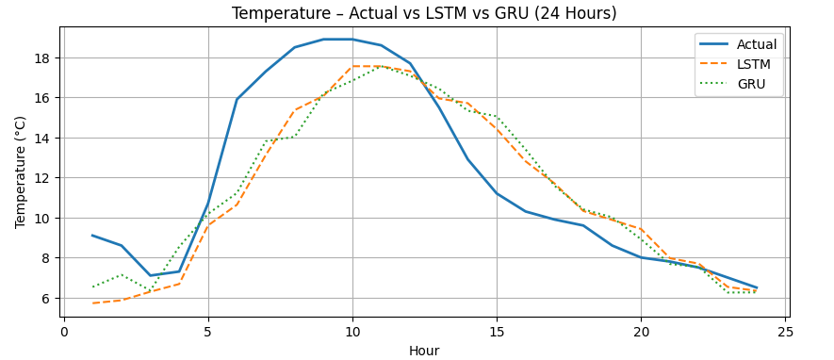
Both models closely follow the actual temperature curve, successfully capturing daily fluctuations.
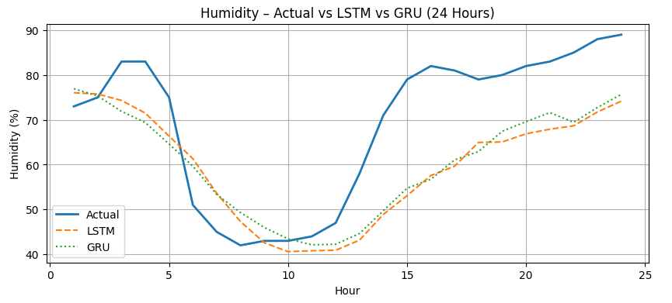
Humidity predictions show moderate deviation but preserve overall trends.
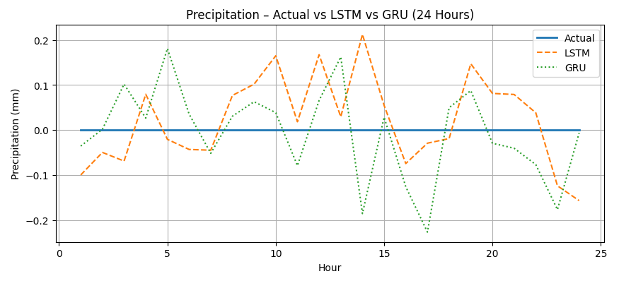
While precipitation is harder to predict due to its irregular nature, the models still identify rainfall patterns reasonably well.
10. Next-Day Weather Forecast
Using the most recent 24 hours of data, both models were employed to predict unseen future conditions.
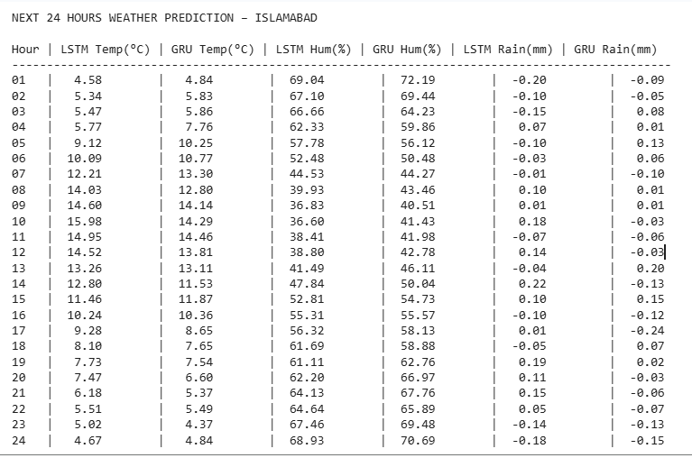 In addition to visual plots, numerical forecasts were generated for each hour, enabling direct interpretation and practical use.
11. Model Saving
The trained LSTM and GRU models were saved in .h5 format to allow future reuse without retraining. This ensures reproducibility and facilitates deployment.
12. Discussion
The results demonstrate that deep learning models can effectively learn temporal dependencies in weather data. LSTM and GRU models perform similarly for temperature and humidity, while precipitation remains challenging due to data sparsity. GRU offers slightly faster training with comparable accuracy.

13. Limitations and Future Work
The study is limited by the duration of the dataset and the exclusion of additional meteorological variables such as wind speed and atmospheric pressure. Future work may involve longer datasets, transformer-based models, and real-time deployment across multiple cities.
14. Conclusion
This project successfully demonstrates a deep learning–based approach for next-day weather forecasting in Islamabad. By leveraging LSTM and GRU networks, the system produces accurate and interpretable forecasts for key weather variables, highlighting the potential of data-driven methods in localized weather prediction.

